Blood vessels provided the template for vertebral and costal pneumatization in sauropod dinosaurs

**Mathew J. Wedel**, College of Osteopathic Medicine of the Pacific and College of Podiatric Medicine, Western University of Health Sciences, Pomona, California, USA. [mathew.wedel@gmail.com](mailto:mathew.wedel@gmail.com)

**Michael P. Taylor**, Department of Earth Sciences, University of Bristol, Bristol BS8 1RJ, UK. [dino@miketaylor.org.uk](mailto:dino@miketaylor.org.uk)

Corresponding author: Mathew J. Wedel, [mathew.wedel@gmail.com](mailto:mathew.wedel@gmail.com)

# Abstract

Pneumatization of the vertebral column by diverticula of the respiratory system was a key innovation in the evolution of sauropod dinosaurs. In extant birds, pneumatic diverticula follow pre-existing blood vessels as they develop. In extant amniotes, arteries and veins enter and leave the vertebrae and ribs in seven locations: (1) the neural arch, (2) roof and walls of the neural canal, (3) flood of the neural canal, (4) ventral surfaces of the transverse processes and inner surfaces of the ribs, (5) lateral surfaces of the centrum, (6) ventral surface of the centrum, and (7) medial surfaces of the haemal arch. Pneumatic fossae and foramina are present in all of these locations in at least some vertebrae and ribs of sauropods, although not all locations may be pneumatized in a single individual, or even across a clade. The close correspondence suggests that sites of vertebral pneumatization in sauropods follow conserved patterns of vertebral vasculature in amniotes. The same relationship of pneumatic features to blood vessels probably existed in non-avian theropods and pterosaurs, but has not yet been documented. In extant amniotes, pneumatic diverticula tend to be variable, opportunistic, and invasive, and these characteristics may explain the occasional appearance of pneumatic features in unexpected places in the vertebrae and ribs of sauropods. The relationships of vascular and pneumatic features in sauropods and other extinct archosaurs could be elucidated by systematic surveys of existing museum collections.

# Introduction

Pneumatization of the vertebral column was a key innovation in the evolution of gigantism in sauropod dinosaurs (Sander et al. 2010, Sander 2013). Pneumatic features vary significantly among taxa (Wedel 2003), among individuals, within the vertebral column of an individual (Wedel and Taylor 2013), and even between the left and right sides of a single individual (Zurriaguz and Alvarez 2014). In extant birds, the pneumatic diverticula that pneumatize the postcranial skeleton follow pre-existing blood vessels (Bremer 1940:200). Blood vessels are highly variable among and within individuals, and to the extent that pneumatic diverticula follow blood vessels, pneumatization will likewise be variable (Wedel and Taylor 2021).

In the present paper we explore the locations where pneumatic features appear on vertebrae and the reasons why they appear in these particular locations.

## Anatomical nomenclature

The term “transverse process” properly refers to processes projecting laterally (or dorsolaterally, posterolaterally, etc.) from the neural arch. It bears the diapophysis with which the tuberculum of the rib articulates. The term is sometimes also used loosely for the processes that extend laterally from caudal vertebrae, but as seen in Figure 1 these are actually coalesced costal elements (caudal ribs). Caudal vertebrae do not have true transverse processes: they are found only in dorsal vertebrae (and in cervicals, although since they are fused to the cervical ribs they are rarely referred to as separate parts of cervical vertebrae).

For clarity, we avoid using the term “transverse process” for costal elements.

## Museum Abbreviations

* AMNH — American Museum of Natural History, New York, New York, USA.
* BIBE — Big Bend National Park, held at Perot Museum of Nature and Science, Dallas, Texas, USA.
* BYU — Brigham Young University Museum of Paleontology, Provo, Utah, USA.
* FMNH — Field Museum of Natural History, Chicago, Illinois, USA.
* MACN — Museo Argentino de Ciencias Naturales “Bernardino Rivadavia”, Buenos Aires, Argentina.
* MB — Humboldt Museum für Naturkunde Berlin, Berlin, Germany.
* NSMT — National Science Museum, Tokyo, Japan.
* RRBP — Rukwa Rift Basin Project, Tanzanian Antiquities Unit, Dar es Salaam, Tanzania.
* YPM — Yale Peabody Museum, New Haven, Connecticut, USA.

# Description

## Vertebral articulation

Virtually all tetrapod vertebrae are composed of the same elements: the centrum, neural arch, haemal arch (chevron), and paired costal elements (Figure 1). Not all elements are present in all vertebrae, and the costal elements may be fused (as is generally the case in the neck, sacrum and tail) or mobile (as is generally the case in the trunk), but this is the general plan.

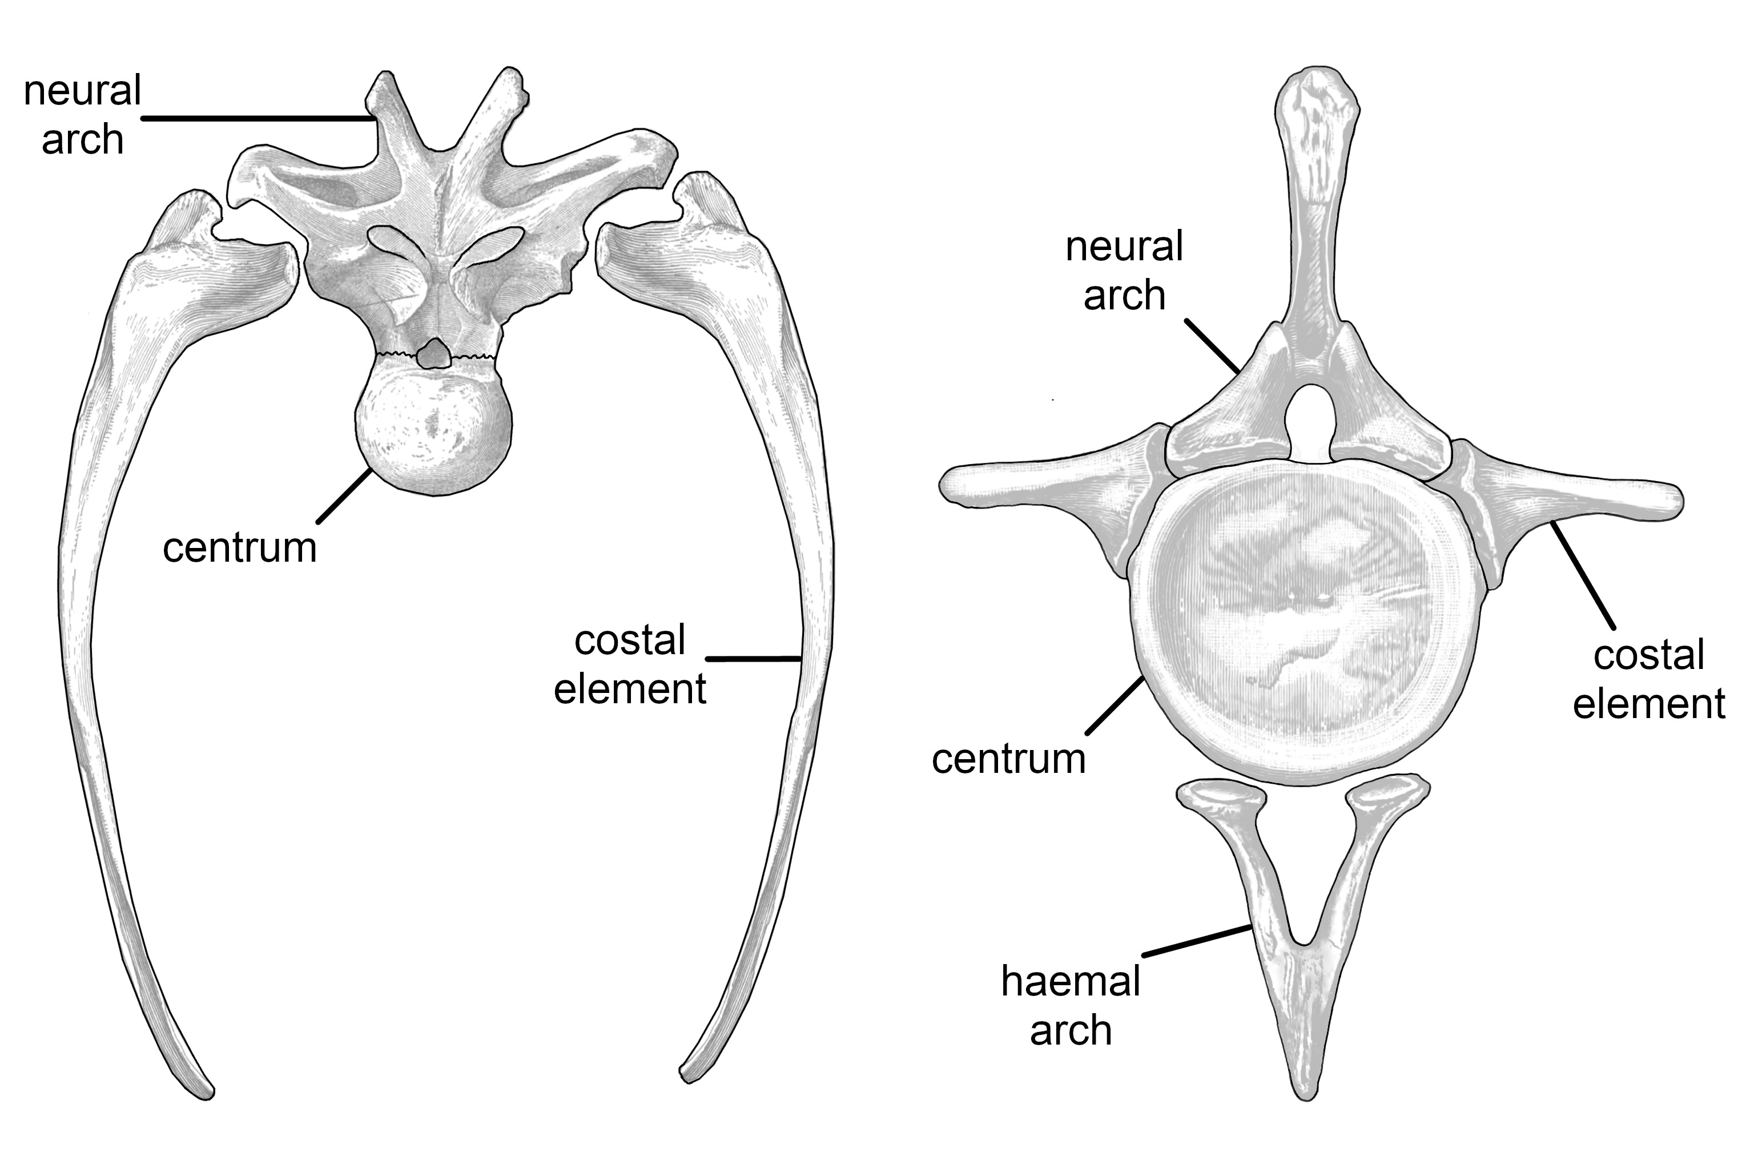

**Figure 1.** Two schematic sauropod vertebrae, showing the homologous ossifications that compose them. **Left:** dorsal vertebra and free ribs. **Right:** caudal vertebra including fused ribs. Note that there no haemal arch in precaudal (cervical, dorsal and sacral) vertebrate. Image composed from dorsal vertebra 4 of *Camarasaurus supremus* AMNH 5760’/D-X-131 in anterior view, modified from Osborn and Mook 1921:plate 70; left rib 4 (mirrored) of *Camarasaurus supremus* AMNH 5761/R-A-24 in anterior view, modified from Osborn and Mook 1921:figure 71; caudal vertebra 2 of *Camarasaurus lentus* (YPM collection, specimen number unknown) in anterior view, modified from Marsh 1896:plate 34, part 4; and chevron of *Camarasaurus grandis* (YPM collection, specimen number unknown) in posterior view, modified from Marsh 1896:plate 39: part 3c.

## Vertebral vascularization

The vertebral elements are served by a system of arteries and veins. Specific branching patterns are variable among individuals and lineages, but the basic plan is highly conserved. Figure 2 shows a generalized consensus of vertebral vascularization in amniotes, based on the descriptive work of Amato et al. (1959), Crock (1960), Smuts (1975); Ratcliffe (1982), and Travan et al. (2015).

In extant amniotes, seven distinct groups of arteries and veins enter or exit the vertebrae at distinctive locations (Table 1): (1) the neural arch; (2) dorsal roof or lateral walls of the neural canal (neural arch elements); (3) ventral floor of the neural canal (centrum); (4) ventral surfaces of the transverse processes, or inner surfaces of the ribs; (5) lateral surfaces of the centrum; (6) ventral surface of the centrum; (7) medial surface of the chevron.

**Table 1. Sites of vertebral vascularization and pneumaticity**

|  |  |  |  |
| --- | --- | --- | --- |
| **#** | **Vascularized element** | **Vascularization site** | **Sauropod pneumaticity example** |
| 1 | Neural arch | Lateral and anterior/posterior surfaces | Neural spine of 8th cervical vertebra of *Giraffatitan* (Figure 4C) |
| 2 | Neural arch | Dorsal roof or lateral walls of the neural canal | Neural canal roof of a cervical vertebrae of *Alamosaurus sanjuanensis* (Figure 4B) |
| 3 | Centrum | Ventral floor of the neural canal | Dorsal vertebral centrum of the titanosaur *Mnyamawamtuka moyowamkia* (Figure 4D) |
| 4 | Costal processes | Ventral surfaces of the transverse processes, and inner surfaces of the ribs | Medial face of dorsal rib of *Brachiosaurus altithorax* (Figure 4E) |
| 5 | Centrum | Lateral surfaces | Centrum of of 8th cervical vertebra of *Giraffatitan* (Figure 4C) |
| 6 | Centrum | Ventral surface | Ventral surface of cervical vertebra of *Giraffatitan* (Figure 4F) |
| 7 | Chevron | Medial surfaces | Medial surface of a chevron of a saltasaurine titanosaur (Figure 4G) |

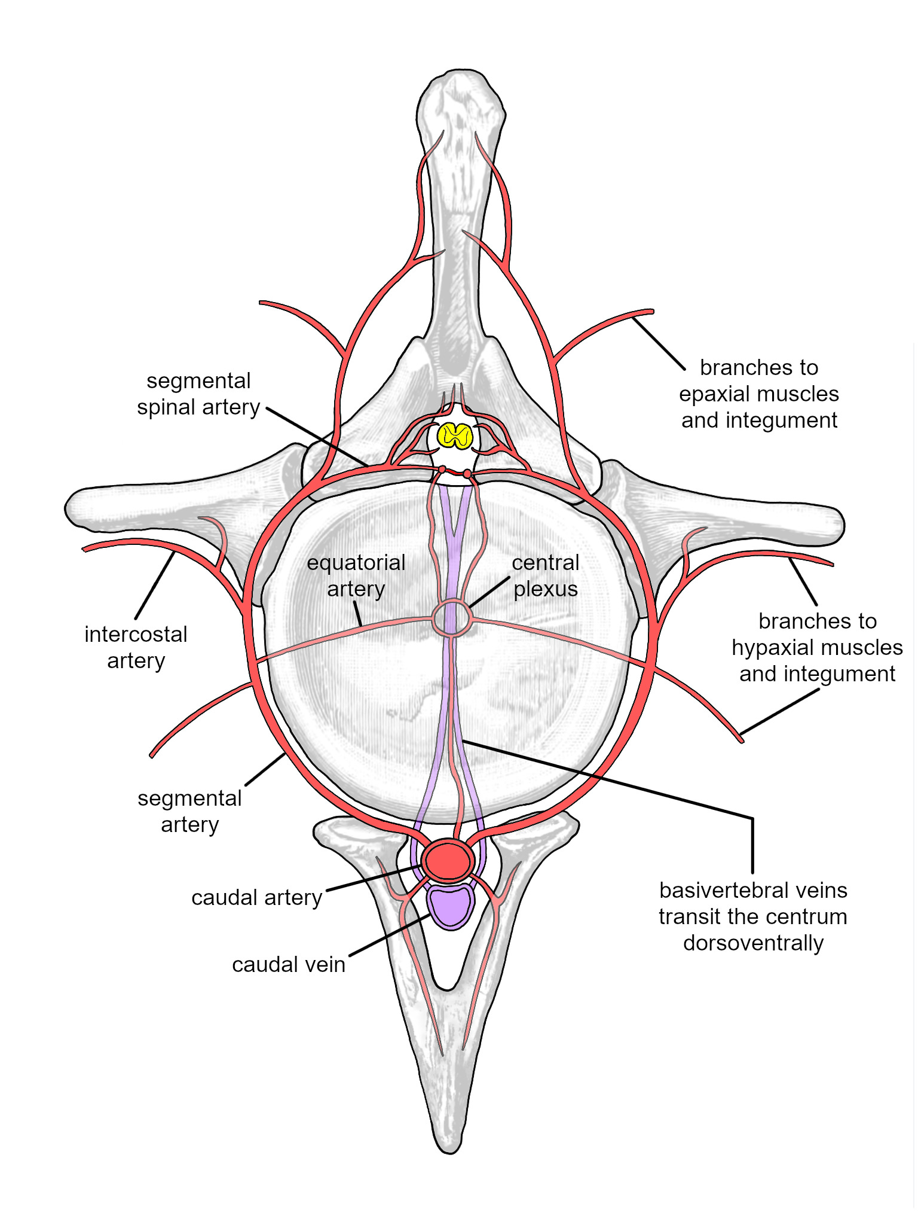

**Figure 2.** Vascularization sites shown on a schematic sauropod vertebra. These sites are largely conserved across Amniota.

## Pneumatic sites in sauropod vertebrae

The seven sites where arteries and veins enter and exit the bones are also the sites where the vertebral elements may be pneumatized by diverticula of the respiratory system (Figure 3).

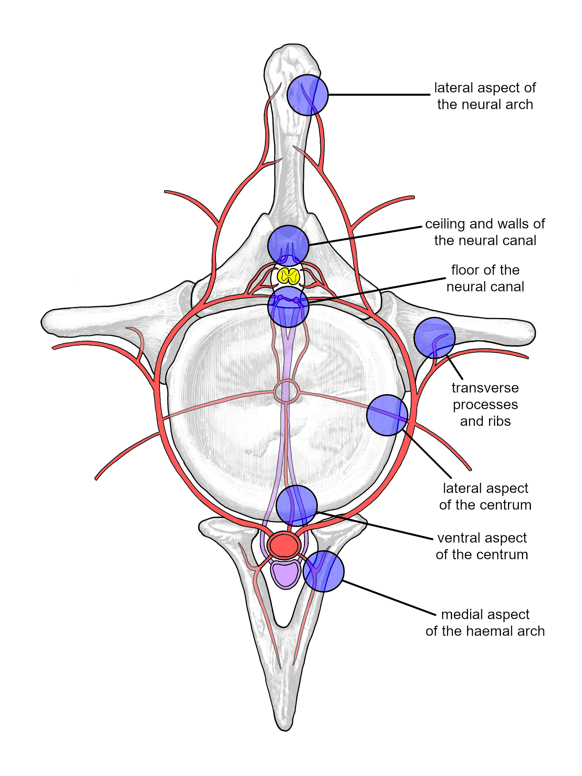

**Figure 3.** The seven sites where arteries and veins enter and exit the bones (see Table 1).

In the skeletons of sauropods, pneumatic fossae and foramina have been documented at all seven of these locations (Figure 4, Table 1), although not all locations may be pneumatized in a single individual, or even across a clade.

The most obvious and best-documented pneumatic traces in sauropod vertebrae are the fossae and foramina on the lateral aspects of the neural arch and centrum (e.g., Wedel 2005:figure 7.2). Also widespread are peduncular fossae: the paired pneumatic fossae or foramina on the anterior or posterior aspect of the neural arch, lateral to the neural canal. These are found in pterosaurs, sauropods, and non-avian theropods, as illustrated and discussed by Taylor and Wedel (2021:figure. 4). These probably also represent pneumatization of the neural arch by the segmental spinal arteries.

Pneumatic openings from the neural canal into the neural arch and centrum are less well-documented, in part because the inner surface of the neural canal is difficult to prepare or observe, especially in proportionally long vertebrae. Nevertheless, a few examples of pneumatic fossae and foramina inside the neural canal have been described, both from CT scans (Schwarz and Fritsch 2006:figure 4H–J; Aureliano et al. 2021:figure 2.3) and from direct observation in broken or unfused specimens (Atterholt and Wedel 2018, Gorscak and O’Connor 2019). The centrodiapophyseal fossae of sauropod presacral vertebrae (Wilson et al. 2011) represent pneumatization of the ventral surfaces of the transverse processes and adjacent regions of the neural arches, presumably by diverticula that followed segmental arteries. The proximal portions of the dorsal ribs are pneumatized in a few diplodocids (Lovelace et al. 2008:figure 9) and in most titanosauriforms (e.g., Janensch 1950:figure 107, Gomani 2005:figure 12, Curry Rogers 2009:figure 30).

Pneumatization of the ventral surface of the centrum has been documented in multiple regions of the vertebral column. In cervical vertebrae, they are found in the referred *Apatosaurus ajax* specimen NSMT-PV 20375 (Upchurch et al. 2005:plate 1K), the Wyoming *Supersaurus* (Lovelace et al. 2008:figure 4A) and the *Giraffatitan brancai* lectotype MB.R.2180 (personal observation) and paralectotype MB.R.2181 (Janensch 1950::figures 40, 42) among others. We have not observed pneumatic features on ventral surfaces of dorsal or sacral vertebrae, despite having looked for them. In caudal vertebrae, ventral pneumaticity is seen in, for example, *Rocasaurus muniozi* MPCA- Pv 54 (Cerda et al. 2012:figure 1G), an indeterminate saltasaurine titanosaur (Zurriaguz et al. 2017:figure 5), and the diplodocoid BYU 11505.

Ventral pneumatization may be more common than currently appreciated due to the difficulty in studying the ventral aspects of large, fragile vertebrae that are often stored upright on bases. This is a rare situation in which mounted sauropod skeletons can be more rather than less scientifically useful than individual elements in collections: they provide an opportunity to view the ventral aspects of large vertebrae.

Finally, pneumatization of the chevrons has been documented in the indeterminate saltasaurine titanosaur MACN-Pv RN 233-4 (Zurriaguz et al. 2017:figure 9). As is often the case with pneumatic features (Wedel and Taylor 2013) it seems possible that this feature also exists in other known elements, but has not been identified because it was not expected. More careful inspection of other sauropod chevrons may present a fruitful opportunity to extend our knowledge in this area.

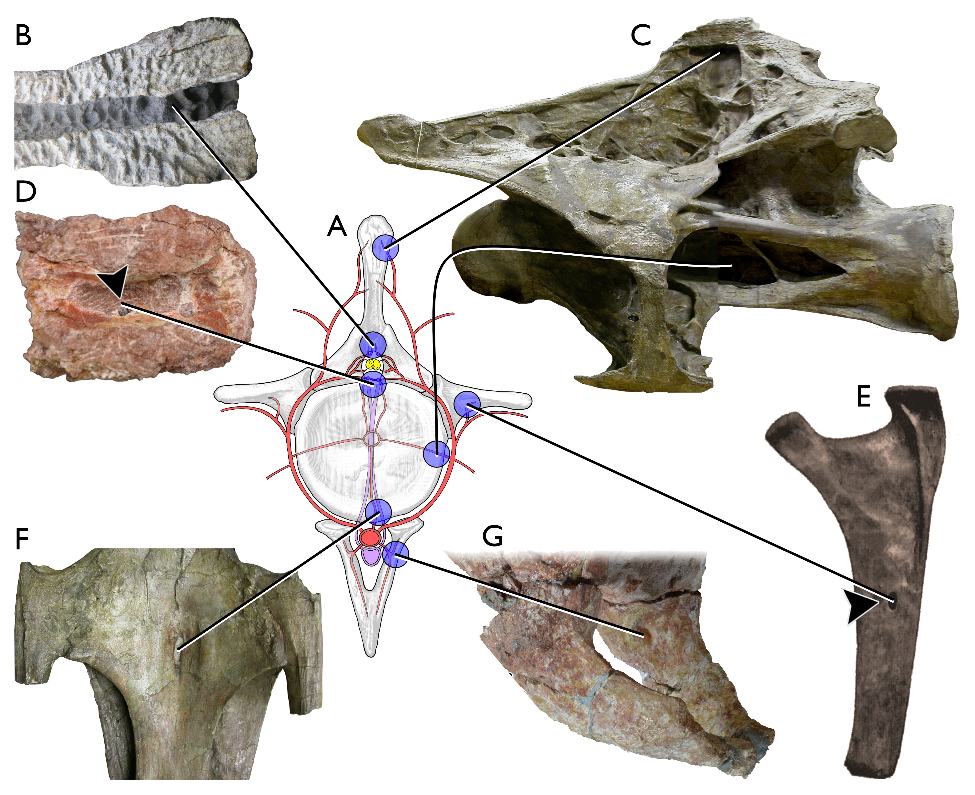

**Figure 4.** Examples of pneumatic structures in sauropod vertebrae matching each of the seven sites of vascularization. **A.** The schematic sauropod caudal vertebra from Figure 3, showing the vascularization sites (blue circles). **B.** Cervical neural arch of the titanosaur *Alamosaurus sanjuanensis* unnumbered BIBE specimen in ventral view (anterior to right), showing pneumatic fossae in the roof of the neural canal. Modified from slide 46 in supplementary information to Atterholt and Wedel (2018). **C.** Cervical vertebra 8 of the brachiosaurid *Giraffatitan brancai* paralectotype MB.R.2181, in left lateral view, showing extensive pneumatic sculpting in the neural spine and a deep pneumatic fossa in the side of the centrum. Photograph by authors. **D.** Dorsal vertebral centrum of the titanosaur *Mnyamawamtuka moyowamkia* holotype RRBP 05834 in dorsal view, anterior to top, showing pneumatic fossa in the floor of the neural canal. Modified from Gorscak and O’Connor (2019:figure 5C). **E.** Dorsal rib of the brachiosaurid *Brachiosaurus altithorax* holotype FMNH PR 25107, showing pneumatic foramen in the medial aspect. Modified from Riggs (1904:plate 75:figure 5). **F.** Cervical vertebra 6 of the brachiosaurid *Giraffatitan brancai* paralectotype MB.R.2181, in ventral view with anterior to the top, showing a distinct pneumatic foramen on the bottom of the centrum. Photograph by authors. **G.** Chevron of indeterminate saltasaurine titanosaur MACN-Pv RN 233-4 in left posterolateral view, showing pneumatic foramen on medial aspect of right portion. Photograph by Virginia Zurriaguz.

# Discussion

## Sites of vascularization are sites of pneumatization

In extant birds, pneumatization of vertebrae follows the paths laid down by blood vessels, so that nutrient foramina are enlarged and become pneumatic foramina leading to internal pneumatic spaces. As discussed by Taylor and Wedel (2021), this developmental pattern explains why bone — usually the least variable material in the vertebrate body — shows so much variation in its pneumatic morphology: pneumatization follows one of the most developmentally labile systems of the body.

In the present study, we have shown that sauropods manifest pneumatic openings in all seven of the sites where blood vessels penetrate vertebrae, corroborating the hypothesis that pneumaticity followed vascularization in sauropods, as it does in birds.

The same relationship of pneumatic features to blood vessels probably existed in other animals with postcranial pneumaticity: non-avian theropods and pterosaurs. The presence of pneumatic features at all seven sites of vascularization has not yet been documented in those clades, but since the known sites of pneumatization are are analogous to those documented here for sauropods (e.g. O’Connor 2006, Claessens et al. 2009, Benson et al. 2012), it would not be surprising if pneumatic features were to be found in all sites within both clades.

## Pneumatic sites unrelated to major blood vessels

Given that no vascular foramina are known on the lateral aspects of chevrons of sauropods, or indeed any animals, we might reasonably predict that pneumatic features will never be found on the lateral aspects of chevrons — that the absence of currently known evidence of lateral pneumaticity is unlikely to be overturned. However, things may not be that simple. As pointed out by Witmer (1997:64), pneumatic diverticula can be viewed as “opportunistic pneumatizing machines, resorbing as much bone as possible within the constraints imposed by local biomechanical loading regimes”. As such, pneumatic variability routinely results in unexpected morphology with a great deal of individual variation. In fact diverticula are even more opportunistic than suggested here by Witmer, as they can make their way through soft-tissue systems as well as bone. For example, gannets have extensive subcutaneous diverticula (Daoust et al. 2008:figure 3). Soft-tissue diverticula similarly unmoored from major blood vessels occasionally find their way back to bone (O’Connor 2004), enabling pneumatic features to develop even in aspects of a bone where no major blood vessel enters.

A few examples of “out of bounds” pneumatization can be found in the literature about sauropods. For example, according to the seven-sites plan outlined above, pneumatic openings in the ribs should be found only on their inner aspects, corresponding to the location of the intercostal arteries. And indeed in the great majority of documented pneumatic ribs, this is the case. However, there are exceptions. For example, right dorsal rib 2 of the well-preserved *Apatosaurus louisae* holotype CM 3018 has a pneumatic foramen on its anterolateral surface (Gilmore 1936:plate 24).

Thus the seven-sites plan discussed herein provides a framework that accounts for the great majority of sauropod pneumaticity, but the opportunistic behavior of diverticula means that this schema cannot be exhaustive. It remains possible that pneumatic features will be found on sites such as the lateral faces of sauropod chevrons.

## Pneumatic features in unusual neural canals

As described by Wedel and Atterholt (2023), in some aberrant sauropod vertebrae the neural canal is enclosed entirely either by the arch or the centrum. Neural canals in these positions will still carry the usual segmental spinal arteries, and as they penetrate the walls of the neural canal they will still have the capacity to carry diverticula with them, creating pneumatic foramina in the roof, walls and floor of the canal. The only difference is that different elements of the vertebra are thereby pneumatized: either all neural-canal pneumatic features penetrate the arch, or they all penetrate the centrum. In other words, the opportunistic behavior of the diverticula remains the same, treating bone as bone without concern for the identity of the bony element that happens to be at hand.

## The mundanity of sauropods

Famously, sauropods attained masses an order of magnitude greater than other terrestrial animals, and much speculation has arisen regarding anatomical novelties that may have enabled this gigantism — e.g. pharyngeal slits for respiration (Gale 1997), multiple accessory hearts in the neck (Choy and Altman 1992), and obligate aquatic habits (as overturned by Kermack 1951, Naish 2012 and others). Such ideas are entertaining but have no basis in fossilized evidence. Instead, the conservatism of the sauropod vascular system, as inferred from patterns of vertebral pneumaticity, provides evidence that they were built just like other animals, rather than being special magical monsters. Axial pneumaticity gives us a window on the fact that, at the most basic level, sauropod skeletons developed much like those of extant amniotes.

## Directions for future research

After roughly a century of only sporadic attention to dinosaurian pneumaticity (e.g., Janensch 1947), work by Witmer (1987, 1995), Britt (1997) and Britt et al. (1998) kicked off a broad resurgence of interest in both cranial and postcranial pneumaticity in dinosaurs and pterosaurs. After the past quarter century of intense work, we now find ourselves in the curious position of knowing far more about pneumaticity in dinosaurs than we do about the underlying vasculature. A systematic survey of vascular foramina in even in a single nearly-complete dinosaur skeleton, like the work done by Smuts (1974, 1975, 1976, 1977a, 1977b) on cattle, would be a welcome advance.

In this paper we have documented that sites of vertebral pneumatization in sauropods correspond with sites of vertebral vascularization in amniotes generally. Further, we have proposed that this correspondence represents causation rather than mere correlation – pneumatic diverticula invaded vertebrae and ribs in stereotyped locations because they followed pre-existing blood vessels as they developed. This hypothesis can be tested by looking for counter-examples to our seven-sites model. The occasional exception, like pneumatization of the outer surface of a dorsal rib in *Apatosaurus louisae*, can be chalked up to the variability and developmental opportunism of pneumatic diverticula (see Witmer 1997), but a large number of exceptions could force a reevaluation of our hypothesis.

Like the collections surveys of Drumheller et al. (2020) and McHugh et al. (2020), both of our proposed investigations — documenting vascular foramina in the skeletons of dinosaurs (and other extinct vertebrates), and searching for pneumatic features in places that might contradict the “blood vessels first” hypothesis — are inherently collections-based projects that could leverage existing resources and involve students and early-career researchers, and they could be done in parallel, separately or collaboratively, across many subject taxa and many institutions. Even if we are mistaken about the morphogenetic basis of pneumaticity, we hope to inspire useful work.

# Acknowledgements

We thank Virginia Zurriaguz for permission to reproduce her photograph of a pneumatic chevron in Figure 4G. We are also grateful to all those who allowed us access to specimens in collections.

# References

Amato, V. P., Sliema Malta and R. Bombelli. 1959. The normal vascular supply of the vertebral column in the growing rabbit. *The Journal of Bone & Joint Surgery British Volume* **41B(4)**:782–795. doi.org:10.1302/0301-620X.41B4.782

Atterholt, Jessie, and Mathew J. Wedel. 2018. A CT-based survey of supramedullary diverticula in extant birds. *PeerJ Preprints* **6**:e27201v2. doi:10.7287/peerj.preprints.27201v2

Aureliano, Tito, Aline M. Ghilardi, Bruno A. Navarro, Marcelo A. Fernandes, Fresia Ricardi-Branco and Mathew J. Wedel. 2021. Exquisite air sac histological traces in a hyperpneumatized nanoid sauropod dinosaur from South America. *Scientific Reports* **11(24207)**. doi:10.1038/s41598-021-03689-8

Benson, Roger B. J., Richard J. Butler, Matthew T. Carrano and Patrick M. O'Connor. 2012. Air-filled postcranial bones in theropod dinosaurs: physiological implications and the “reptile”-bird transition. *Biological Reviews* **87**:168-193. doi:10.1111/j.1469-185X.2011.00190.x

Bremer, John L. 1940 The pneumatization of the humerus in the common fowl and the associated activity of theelin. *The Anatomical Record* **77(2)**:197–211. doi:10.1002/ar.1090770209

Britt, Brooks B. 1997. Postcranial pneumaticity. pp. 590–593 in: Philip J. Currie and Kevin Padian (eds). *The Encyclopedia of Dinosaurs*. Academic Press, San Diego.

Britt, Brooks B., Peter J. Makovicky, Jacques Gauthier & Niels Bonde. 1998. Postcranial pneumatization in *Archaeopteryx*. *Nature* 395:374–376.

Cerda, Ignacio A., Leonardo Salgado and Jaime E. Powell. 2012. Extreme postcranial pneumaticity in sauropod dinosaurs from South America. *Paläontologische Zeitschrift* **86**:441–449. doi:10.1007/s12542-012-0140

Claessens, Leon P. A. M., Patrick M. O'Connor, and David M. Unwin. 2009. Respiratory evolution facilitated the origin of pterosaur flight and aerial gigantism. *PLOS ONE* **4(2)**: e4497. doi:10.1371/journal.pone.0004497

Choy, D. S. J., and P. Altmann. 1992. The cardiovascular system of *Barosaurus*: an educated guess. *Lancet* **340(8818)**:534-536.

Crock, H. V. 1960. The arterial supply and venous drainage of the vertebral column of the dog. *Journal of Anatomy* **94(1)**:88–99.

Curry Rogers, Kristina. 2009. The postcranial osteology of *Rapetosaurus krausei* (Sauropoda: Titanosauria) from the Late Cretaceous of Madagascar. *Journal of Vertebrate Paleontology* **29(4)**:1046-1086. doi:10.1671/039.029.0432

Daoust, P.-Y., G. V. Dobbin, R. C. F. Ridlington Abbott and S. D. Dawson. 2008. Descriptive anatomy of the subcutaneous air diverticula in the Northern Gannet *Morus bassanus*. *Seabird* **21**:64–76.

Drumheller, Stephanie K., Julia B. McHugh, Miriam Kane, Anja Riedel and Domenic C. D’Amore. 2020. High frequencies of theropod bite marks provide evidence for feeding, scavenging, and possible cannibalism in a stressed Late Jurassic ecosystem. *PLOS ONE* **15(5)**:e0233115. doi:10.1371/journal. pone.0233115

Gale, H. H. 1997. Breathing through a long neck: sauropod lung ventilation. *Journal of Vertebrate Paleontology* **17(Suppl. to No. 3)**:48A.

Gilmore, Charles W. 1936. Osteology of *Apatosaurus* with special reference to specimens in the Carnegie Museum. *Memoirs of the Carnegie Museum* **11**:175–300 and plates XXI–XXXIV.

Gomani, Elizabeth M. 2005. Sauropod dinosaurs from the Early Cretaceous of Malawi, Africa. *Palaeontologia Electronica* **8(1)**:27A (37 pp.)

Gorscak, Eric, and Patrick M. O’Connor. 2019, A new African titanosaurian sauropod dinosaur from the middle Cretaceous Galula Formation (Mtuka Member), Rukwa Rift Basin, Southwestern Tanzania. *PLOS ONE* **14(2)**:e0211412. doi:10.1371/journal.pone.0211412

Janensch, Werner. 1950. Die Wirbelsaule von *Brachiosaurus brancai*. *Palaeontographica* (Suppl. 7) **3**:27-93.

Kermack, Kenneth A. 1951. A note on the habits of sauropods. *Annals and Magazine of Natural History*, series 12, **4**:830–832.

Lovelace, David M., Scott A. Hartman and William R. Wahl. 2008. Morphology of a specimen of *Supersaurus* (Dinosauria, Sauropoda) from the Morrison Formation of Wyoming, and a re-evaluation of diplodocid phylogeny. *Arquivos do Museu Nacional, Rio de Janeiro*, **65(4)**:527–544.

Marsh, Othniel. C. 1896. *The Dinosaurs of North America*. Extract from the 16th annual report of the U. S. Geological Survey, 1894–95, part I, pp. 133-244 and plates II–LXXXV. doi:10.5962/bhl.title.60562

McHugh, Julia B., Stephanie K. Drumheller, Anja Riedel and Miriam Kane. 2020. Decomposition of dinosaurian remains inferred by invertebrate traces on vertebrate bone reveal new insights into Late Jurassic ecology, decay, and climate in western Colorado. *PeerJ* **8**:e9510. doi:10.7717/peerj.9510

Naish, Darren. 2012. Palaeontology bites back. *Lab News*, **May 2012**:31–32.

O'Connor, Patrick M. 2004. Pulmonary pneumaticity in the postcranial skeleton of extant Aves: a case study examining Anseriformes. *Journal of Morphology* **261**:141–161.

O'Connor, Patrick M. 2006. Postcranial pneumaticity: an evaluation of soft-tissue influences on the postcranial skeleton and the reconstruction of pulmonary anatomy in archosaurs. *Journal of Morphology* **267(10)**:1199–1226. doi: 10.1002/jmor.10470

Osborn, Henry Fairfield, and Charles C. Mook. 1921. *Camarasaurus*, *Amphicoelias* and other sauropods of Cope. *Memoirs of the American Museum of Natural History*, new series, **3**:247-387, and plates LX-LXXXV.

Ratcliffe, J. F. 1982. An evaluation of the intra-osseous arterial anastomoses in the human vertebral body at different ages. A microarteriographic study. *Journal of Anatomy* **134(2)**:373–382.

Riggs, Elmer S. 1904. Structure and relationships of opisthocoelian dinosaurs. Part II, the Brachiosauridae. *Field Columbian Museum, Geological Series* **2(6)**:229–247, plus plates LXXI–LXXV.

Sander, P. Martin, Andreas Christian, Marcus Clauss, Regina Fechner, Carole T. Gee, Eva-Maria Griebeler, Hanns-Christian Gunga, Jürgen Hummel, Heinrich Mallison, Steven F. Perry, Holger Preuschoft, Oliver W. M. Rauhut, Kristian Remes, Thomas Tütken, Oliver Wings and Ulrich Witzel. 2010. Biology of the sauropod dinosaurs: the evolution of gigantism. *Biological Reviews* **86**:117–155. doi:10.1111/j.1469-185X.2010.00137.x

Sander, P. Martin. 2013. An evolutionary cascade model for sauropod dinosaur gigantism – overview, update and tests. *PLOS ONE* **8(10):**e78573. doi:10.1371/journal.pone.0078573

Schwarz, Daniela, and Guido Fritsch. 2006. Pneumatic structures in the cervical vertebrae of the Late Jurassic Tendaguru sauropods *Brachiosaurus brancai* and *Dicraeosaurus*. *Eclogae Geologicae Helvetiae* **99 (1)**:65–78. doi:10.1007/s00015-006-1177-x

Smuts, Malie. M. S. 1974. The foramina of the cervical vertebrae of the ox. Part I: Atlas and Axis. *Anatomia, Histologia, Embryologia* **3**:296–307.

Smuts, Malie M. S. 1975. The foramina of the cervical vertebrae of the ox, part II: cervical vertebrae 3–7. *Anatomia, Histologia, Embryologia* **4(1)**:24–37.

Smuts, Malie. M. S. 1976. Areas of muscular attachment and their correlation with foraminous areas of the cervical vertebrae of the ox (*Bos taurus L*.). *Anatomia, Histologia, Embryologia* **5**:253–266.

Smuts, Malie M. S. 1977a. The arterial blood supply of the cercival vertebrae of the ox (*Bos taurus L*.). *Onderstepoort Journal of Veterinary Research* **44(2)**:95–106.

Smuts, Malie M. S. 1977b. The venous drainage of the cervical vertebrae of the ox (*Bos taurus L*.). *Onderstepoort Journal of Veterinary Research* **44(4)**:233–248.

Taylor, Michael P., and Mathew J. Wedel. 2021. Why is vertebral pneumaticity in sauropod dinosaurs so variable? (version 5) *Qeios* **1G6J3Q.5**. doi: 10.32388/1G6J3Q.5 <https://www.qeios.com/read/1G6J3Q.5>

Travan, Luciana, Paola Saccheri, Giorgia Gregoraci, Chiara Mardegan and Enrico Crivellato. 2015. Normal anatomy and anatomic variants of vascular foramens in the cervical vertebrae: a paleo-osteological study and review of the literature. *Anatomical Science International* **90**:308–323. doi:10.1007/s12565-014-0270-x

Upchurch, Paul, Yukimitsu Tomida, and Paul M. Barrett. 2005. A new specimen of *Apatosaurus ajax* (Sauropoda: Diplodocidae) from the Morrison Formation (Upper Jurassic) of Wyoming, USA. *National Science Museum Monographs* 26. Tokyo. ISSN 1342-9574.

Wedel, Mathew J. 2003. The evolution of vertebral pneumaticity in sauropod dinosaurs. *Journal of Vertebrate Paleontology* **23(2)**:344–357. doi:10.1671/0272-4634(2003)023%5B0344:TEOVPI%5D2.0.CO;2

Wedel, Mathew J. 2005. Postcranial skeletal pneumaticity in sauropods and its implications for mass estimates. pp. 201-228 in Wilson, J. A., and Curry Rogers, K. (eds.), *The Sauropods: Evolution and Paleobiology*. University of California Press, Berkeley.

Wedel, Mathew J., and Michael P. Taylor 2013. Caudal pneumaticity and pneumatic hiatuses in the sauropod dinosaurs *Giraffatitan* and *Apatosaurus*. *PLOS ONE* **8(10)**:e78213. 14 pages. doi: 10.1371/journal.pone.0078213

Wedel, Mathew J., and Jessie Atterholt. 2023. Expanded neurocentral joints in the vertebrae of sauropod dinosaurs. pp. 256–257 in: Hunt-Foster, ReBecca K., James I. Kirkland and Mark A. Loewen (eds), *14th Symposium on Mesozoic Terrestrial Ecosystems and Biota*. *The Anatomical Record* **306(S1)**.

Wilson, Jeffrey A, Michael D. D'Emic, Takehito Ikejiri, Emile M. Moacdieh and John A. Whitlock. 2011. A Nomenclature for vertebral fossae in sauropods and other saurischian dinosaurs. *PLOS ONE* **6(2)**:e17114. doi:10.1371/journal.pone.0017114

Witmer, Lawrence M. 1987. The nature of the antorbital fossa of archosaurs: shifting the null hypothesis. pp. 230–235 in: Philip J. Currie and E. H. Koster (eds). *Fourth Symposium on Mesozoic Terrestrial Ecosystems, Short Papers*. Occasional Paper of the Tyrrell Museum of Palaeontology #3, Drumheller, Alberta.

Witmer, Lawrence M. 1997. The evolution of the antorbital cavity of archosaurs: a study in soft-tissue reconstruction in the fossil record with an analysis of the function of pneumaticity. *Journal of Vertebrate Paleontology* **17(S1)**:1–76. doi:10.1080/02724634.1997.10011027

Zurriaguz, Virginia L., and A. Álvarez. 2014. Shape variation in presacral vertebrae of saltasaurine titanosaurs (Dinosauria, Sauropoda). *Historical Biology* **26(6)**:801–809. doi:10.1080/08912963.2013.858248

Zurriaguz, Virginia, Agustín Martinelli, Guillermo W. Rougier and Martín D. Ezcurra. 2017. A saltasaurine titanosaur (Sauropoda: Titanosauriformes) from the Angostura Colorada Formation (upper Campanian, Cretaceous) of northwestern Patagonia, Argentina. *Cretaceous Research* **75**:101–114. doi:10.1016/j.cretres.2017.03.016